ACCESS MANAGEMENT
Solutions to the problems due to unassigned custom roles
We have seen problems due to unassigned custom roles in earlier post (snowflake_49)
Now, solution to it is if you have custom roles created, you have to create a tree of the custom role and top of tree should be assigned to sysadmin role.
This solves our problem1
Let’s see it practically
Here is a diagram that we are going to assign custom roles mainly to sysadmin
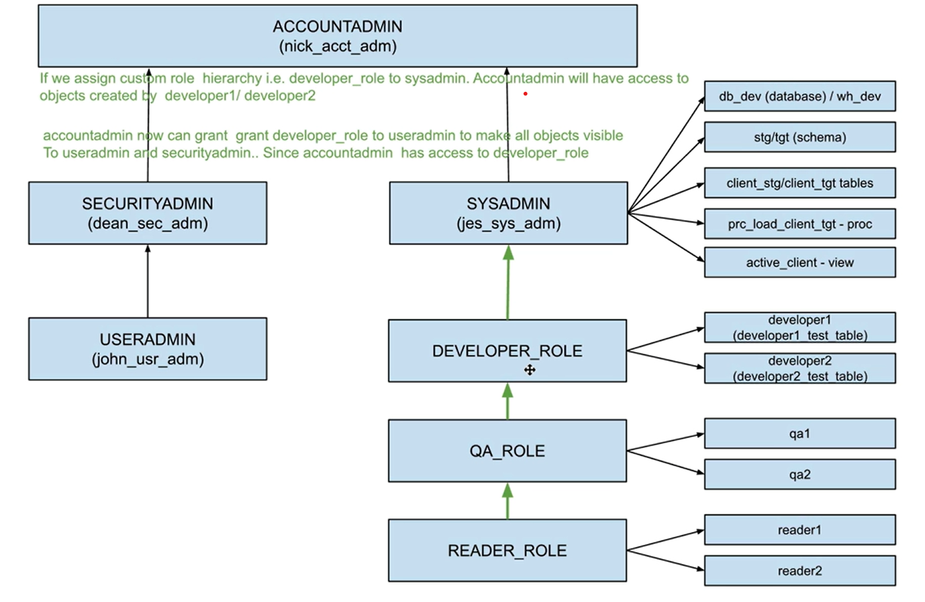

Let’s login to user admin
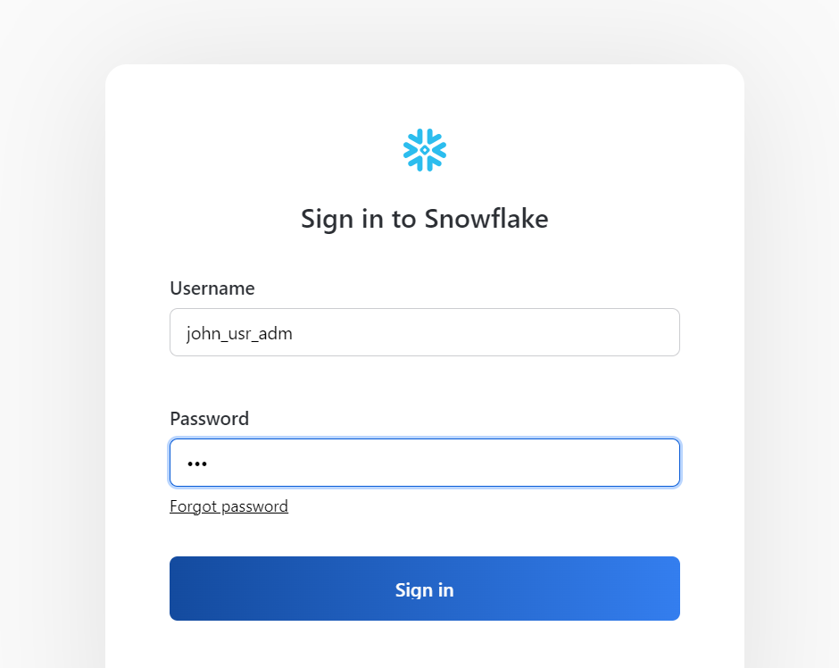
Grant read_role to qa_role as per the hierarchy shown in starting page image
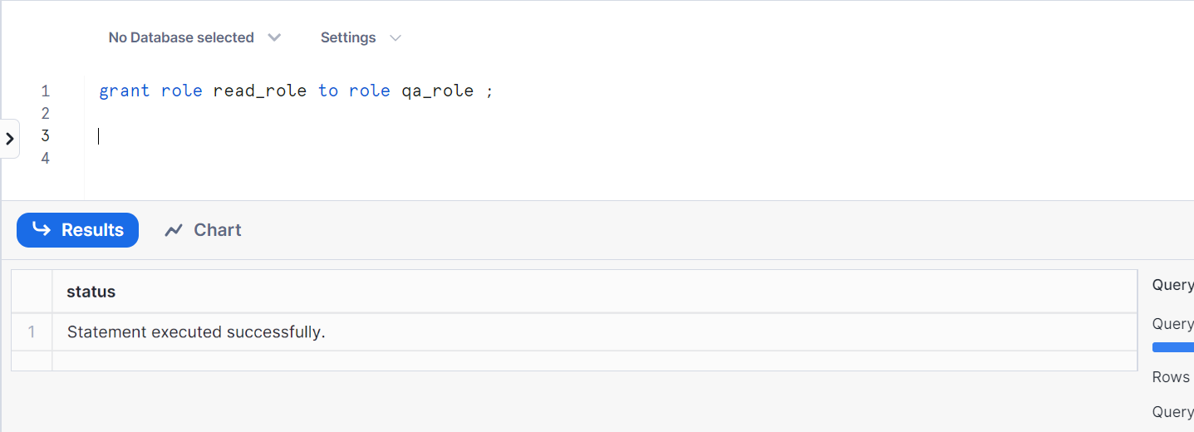

Grant qa_role to developer_role
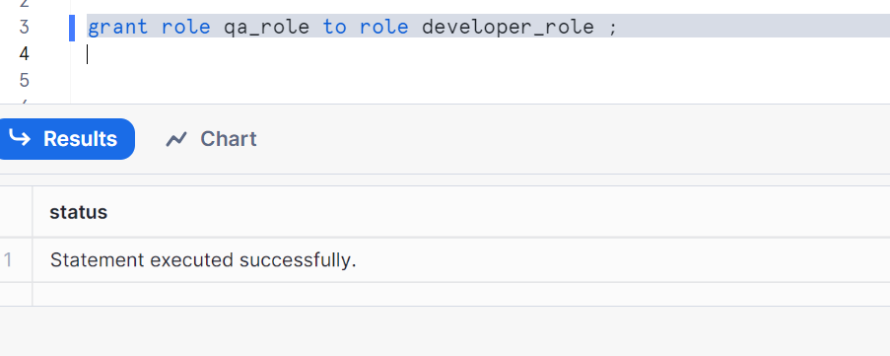
Grant developer_role to sysadmin
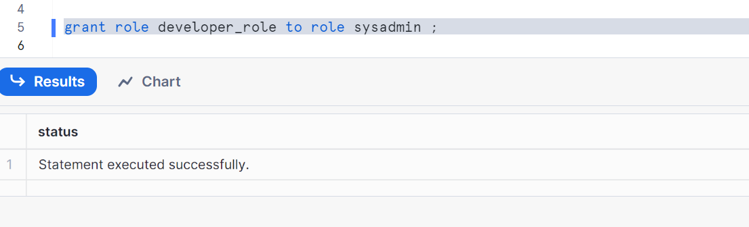

Now let’s go to account admin role and validate
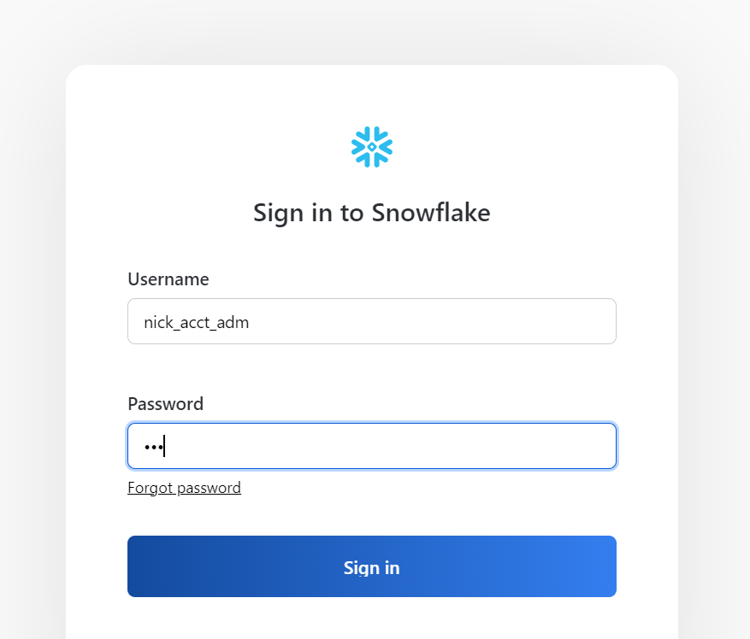
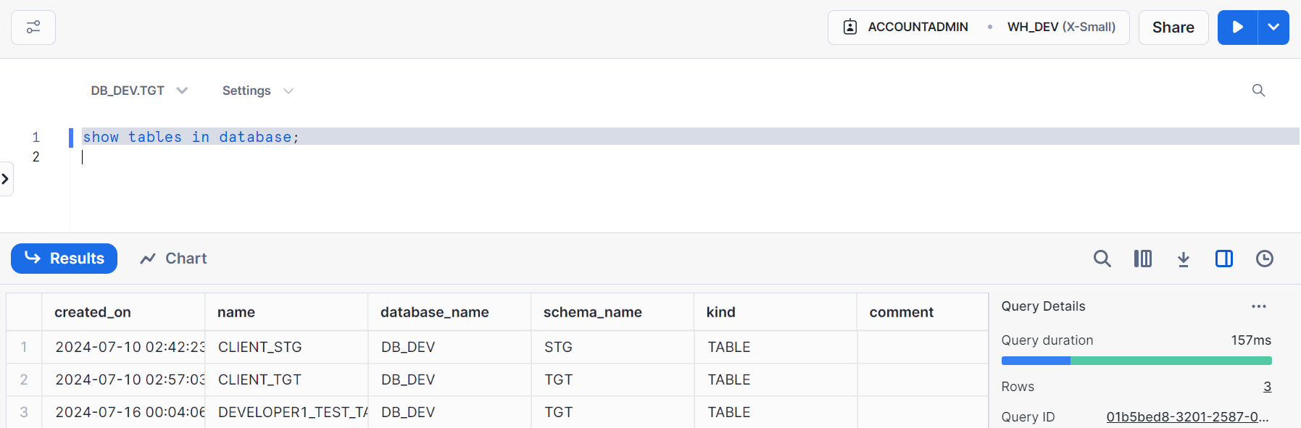
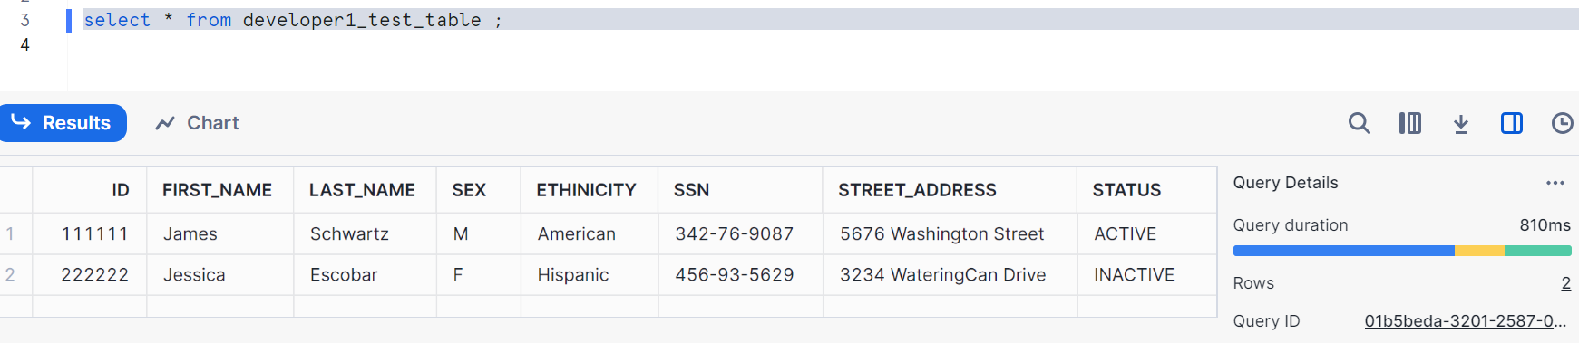
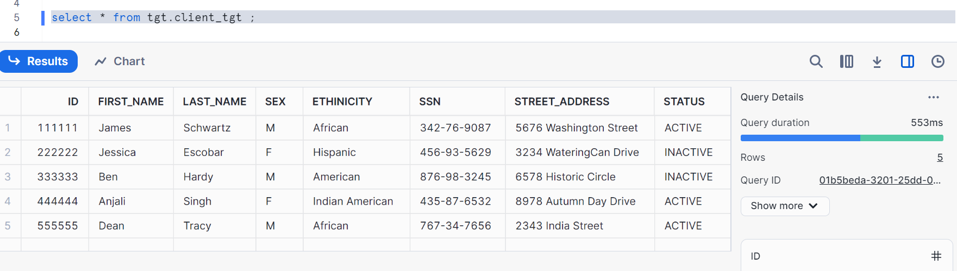
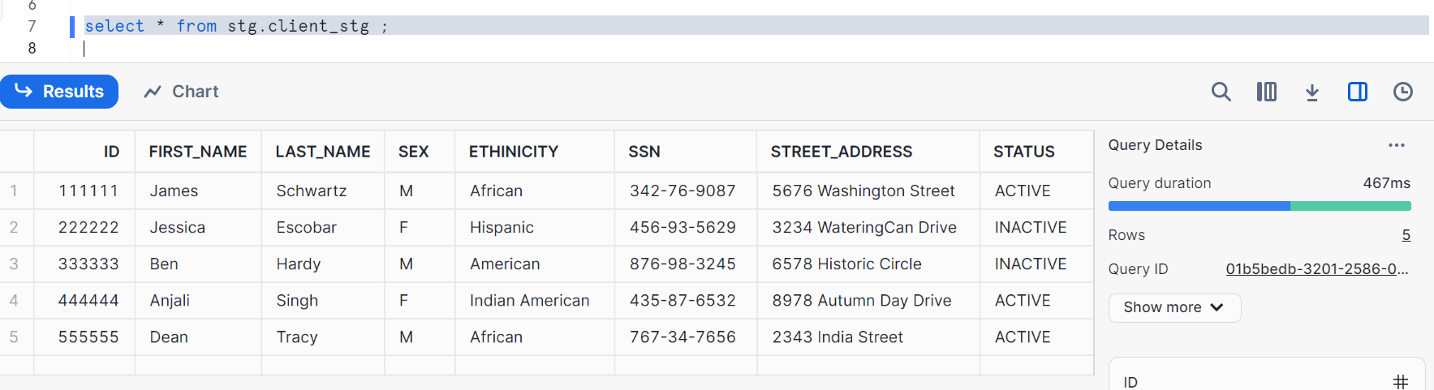
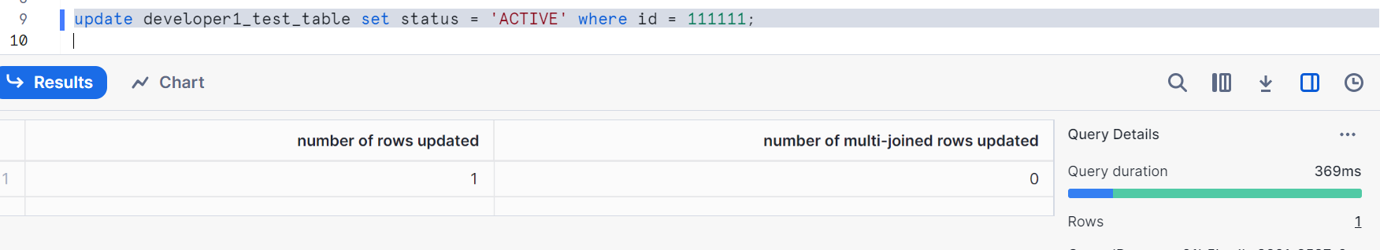
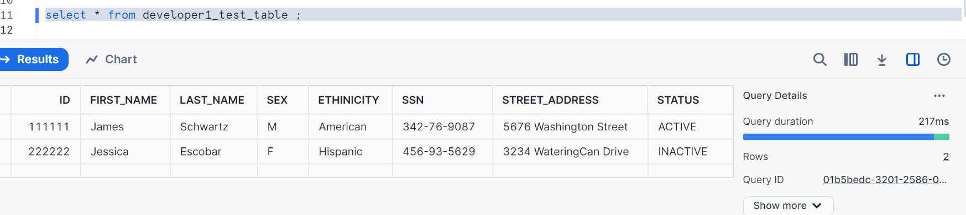
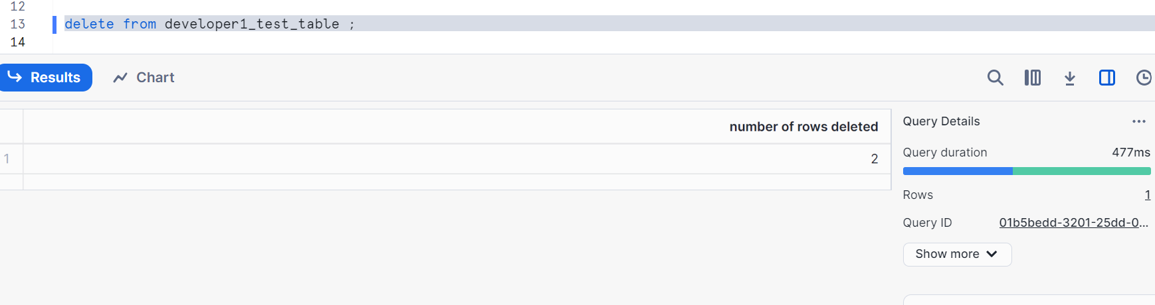
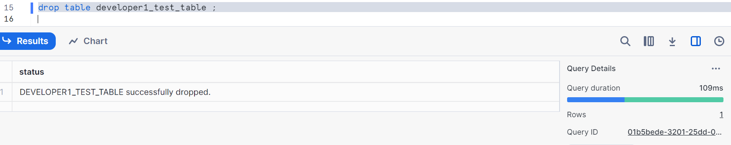
So, the problem1 is resolved by giving grants in user admin role via tree of the custom roles and top of tree should be assigned to sysadmin role.

Now, let’s see solution2
As we know we don’t have access for user admin and security admin roles on database objects created via sysadmin
So, let’s give grant i.e. developer_role to user admin role from account admin role as you have access to developer_role now in account admin.
So that user admin and security admin gets the access to database objects in sysadmin and custom roles like developer role etc. (note: If you analyze carefully, you are getting access indirectly as account admin is connected to security admin)

As you are in the account admin, give grants as following
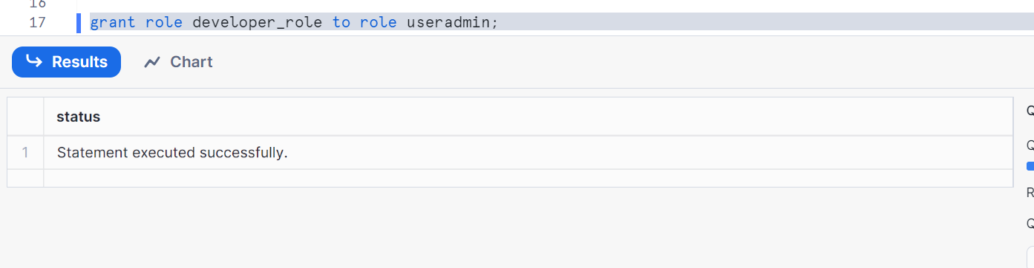
Let’s validate in user admin role
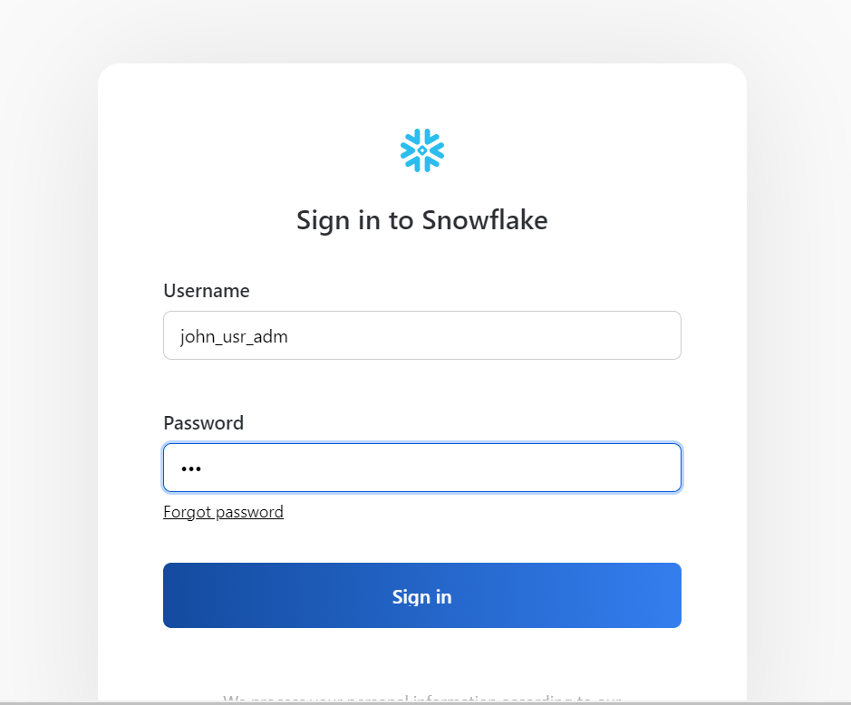
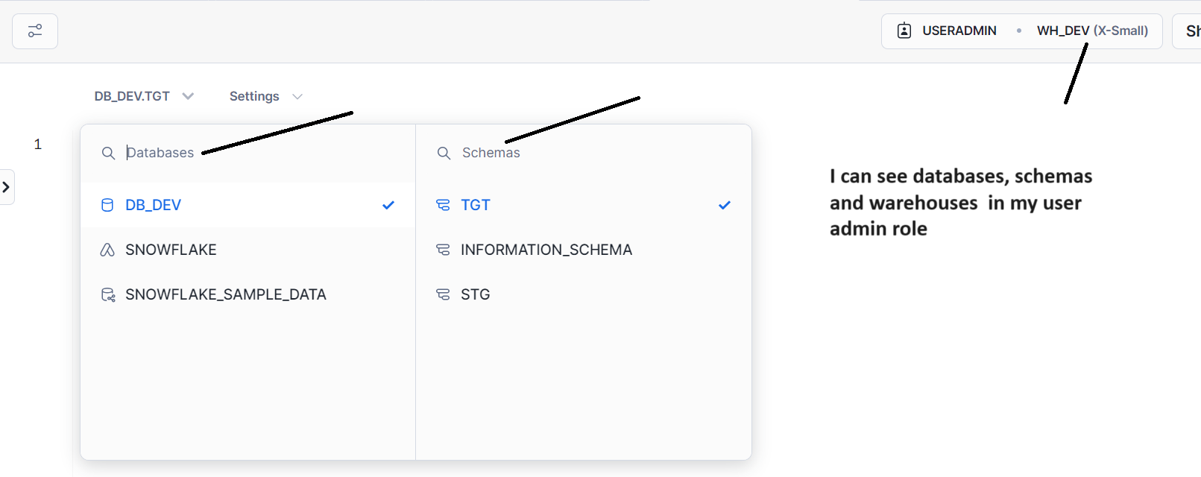

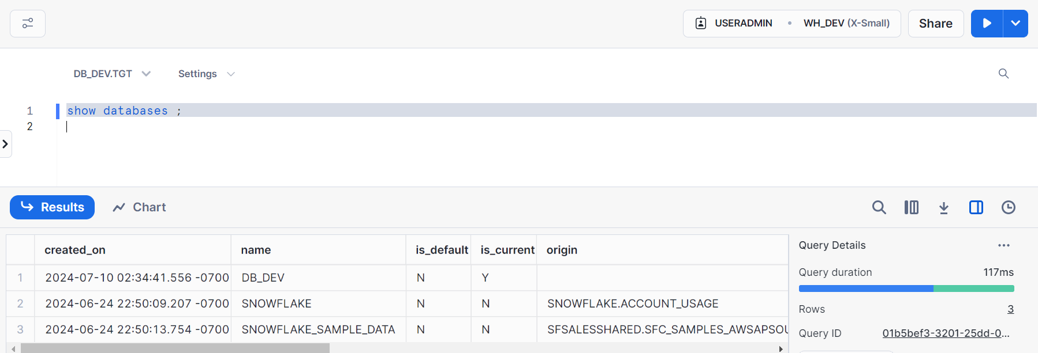
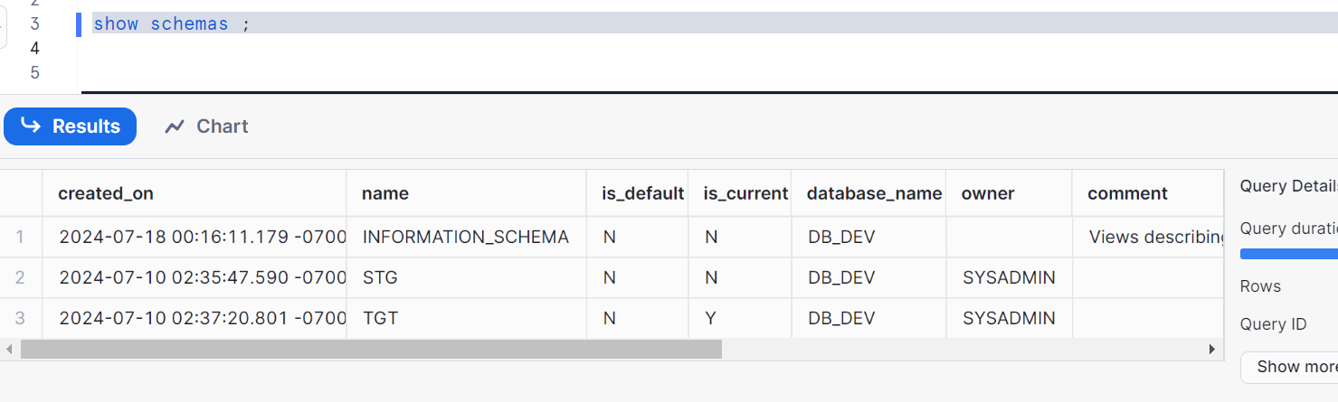
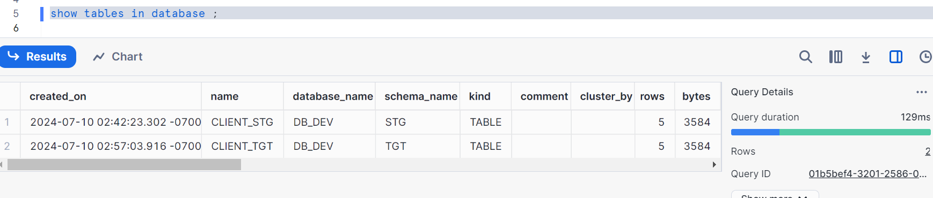
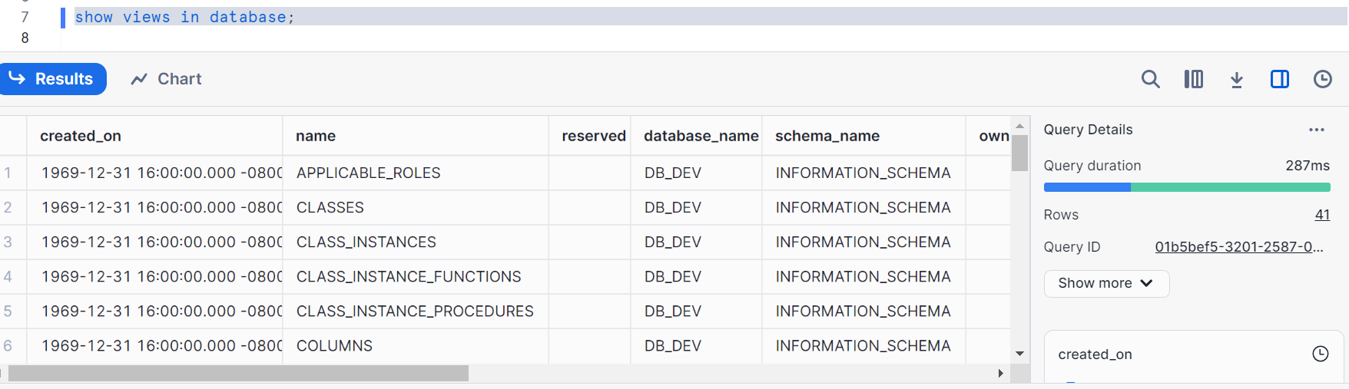
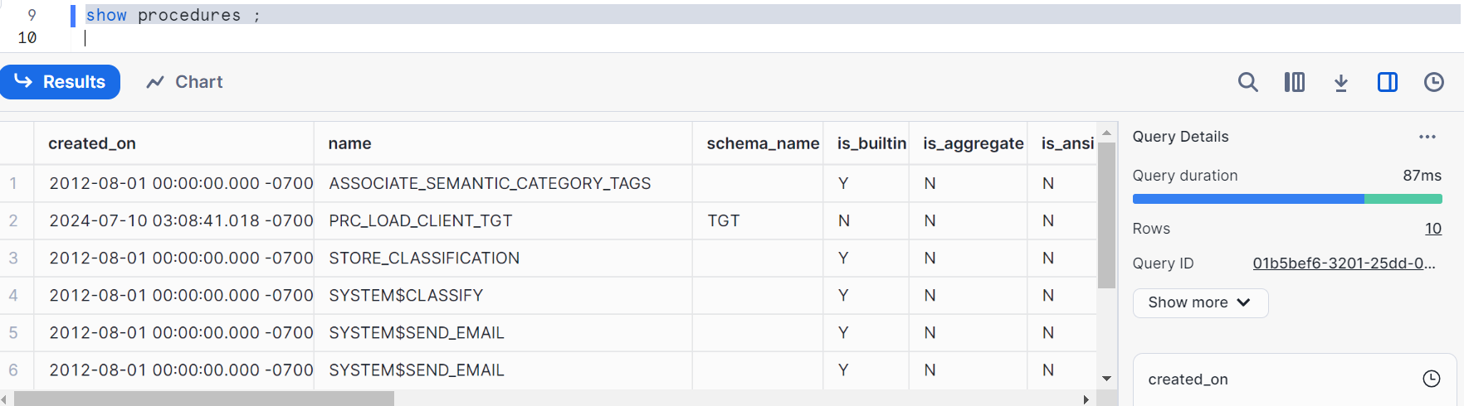
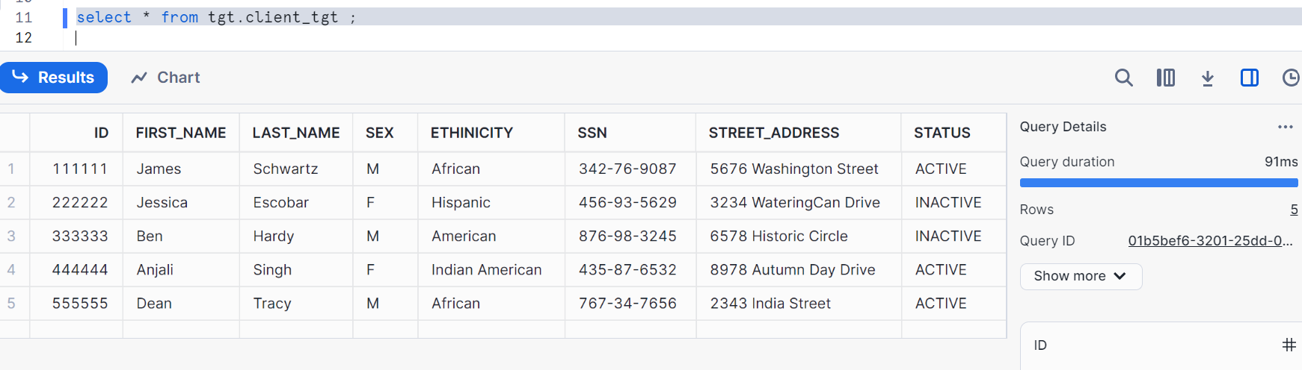
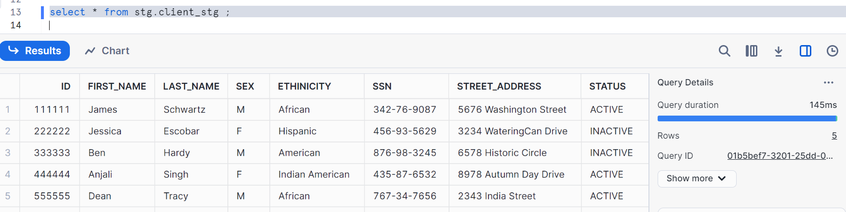
Select * from developer1_test_table;
(Please run this as well as I had dropped this table above, so I am not recreating again)
We can now see that database / Schema and Warehouses in our user admin role

Let’s go to security admin and validate
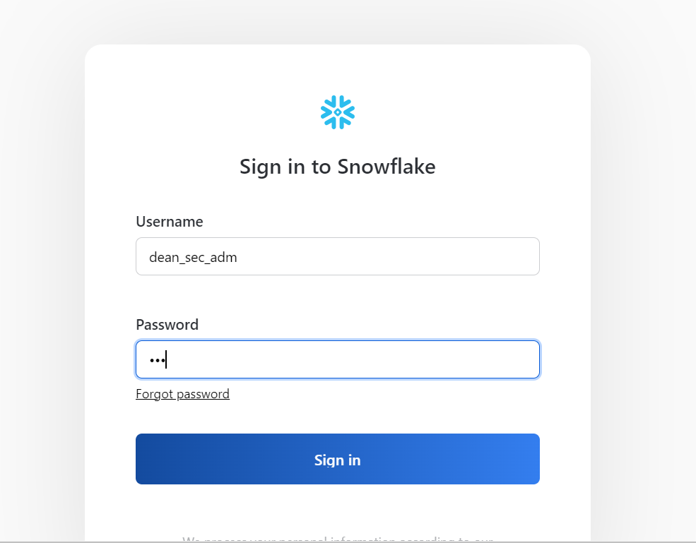
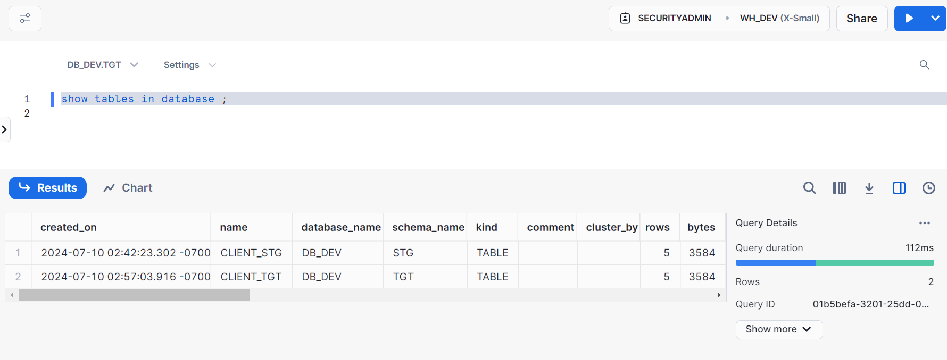
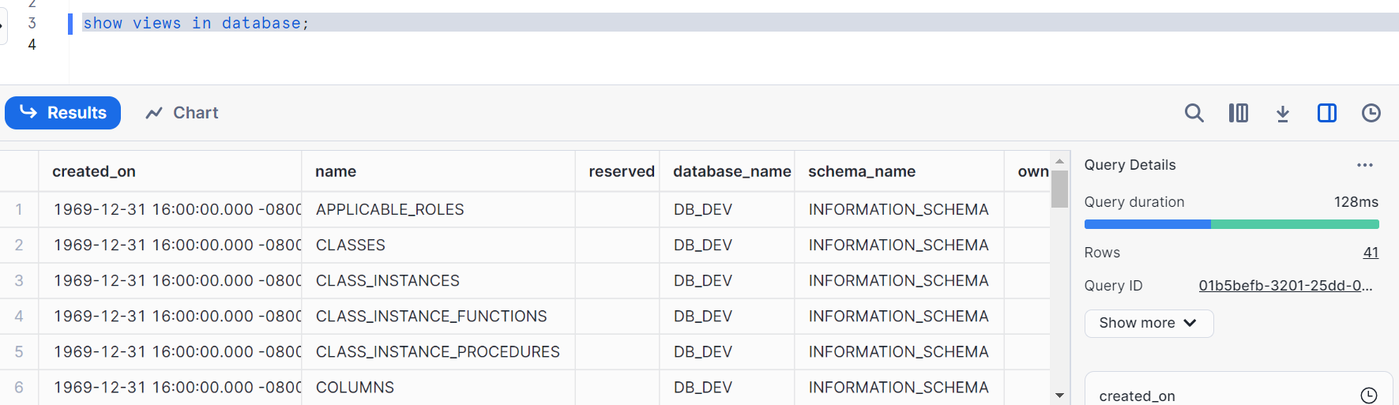
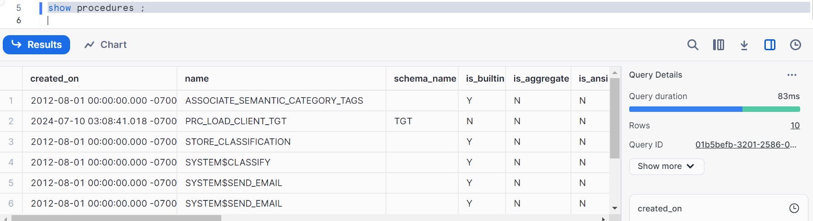
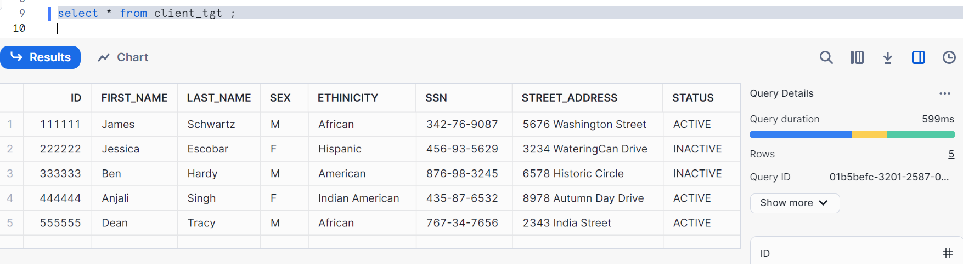
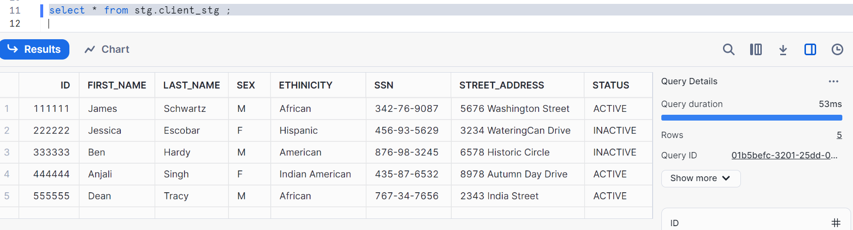
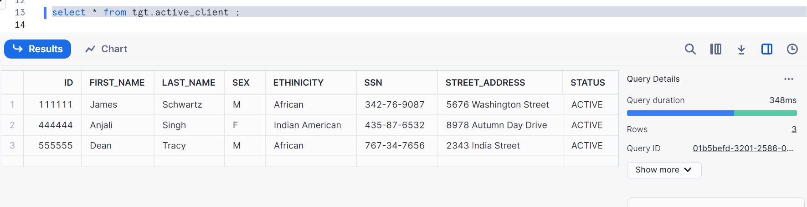
We can now see that database, Schema and Warehouse in our security admin role
Our problem got resolved now

Thanks

